Farmers Cooperative Association of Guam

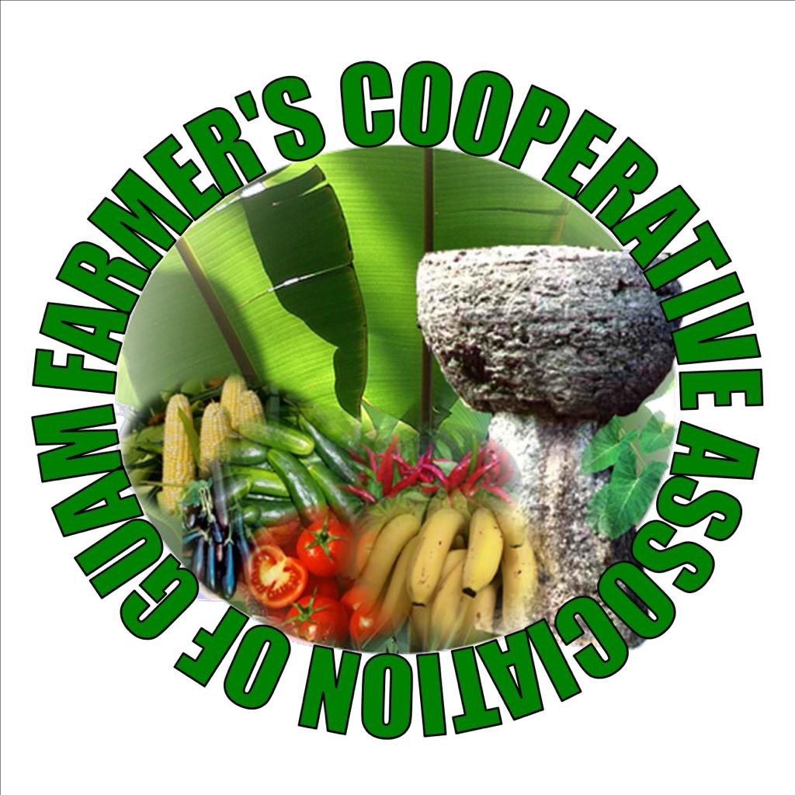

144 W. Santa Monica Ave, Dededo, GU 96929

fcaguam@gmail.com

December 3, 2021

Farmer’s Cooperative Association of Guam, Inc.

A non-profit Corporation

The Farmer’s Cooperative Association of Guam (FCAG) with the assistance of its advisors from University of Guam (UOG) Cooperative Extension & Outreach (E&O) (Dr. Barber & Mr. Bamba) are offering this list of produce items for the “Mixed local produce bag initiative” to the Department of Public Health & Social Services (DPHSS), Division of Senior Citizens (DSC.) This service offer is for 2,700 bags (Congregate Nutrition Program (C1) 1,275 bags and Home-Delivered Nutrition Program (C2) 1,425 bags.) The price will be $8 a bag.

The following produce items will be options for the proposed $8.00 bag during this time period.

1. Bean sprouts

2. Cucumber

3. Eggplant

4. Kangkung

Possible Substitutes:

* 1. Pechay
  2. Bok choy
  3. Green beans
  4. Radish

Should purchase order approval take longer substitutions may need to be made based on availability but this will not change the price of the bags.

"Delivery for the congregate group of senior's will be to the respective village Mayor's Office over three days in the first week.  Delivery for home-delivered group of seniors will be to the vendor, S.H. Enterprises, Inc., who will assist with distribution to clients.  Proposed delivery will be on December 20-22, 2021."

If you have any questions, please call me at 671-797-1844.

Si Yu'us Ma'ase,

Kathrina Reyes

Kathrina S.N Reyes

FCAG Treasurer